# Windows 10 OS Installation

First and foremost, you should ensure your PC meets the minimum [Windows 10 system requirements](https://www.microsoft.com/en-hk/windows/windows-10-specifications). For that, you should go to Microsoft's official site for reference. You can perform the steps below if the computer meets the minimum requirements.

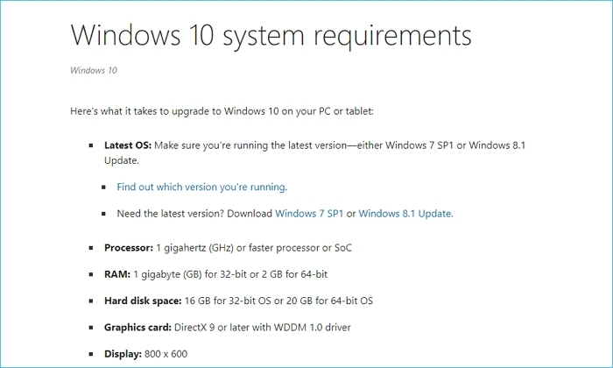

**Step 1:** Search “Windows 10 download” on your internet browser and download the file to a USB drive with a minimum of 8GB space. Download and open it. *Note: the drive will be formatted*

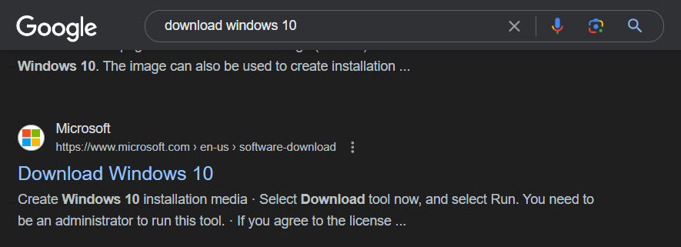

**Step 2:** Accept the terms choose the option to create an installation media and click next.

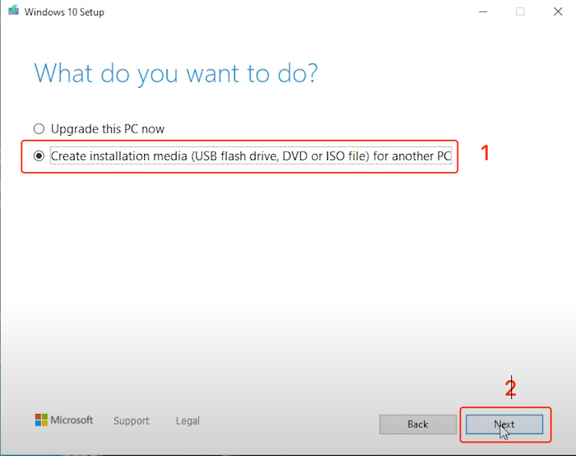

**Step 3:** Keep the recommended options checkbox checked, click next and choose USB flash drive option then click next

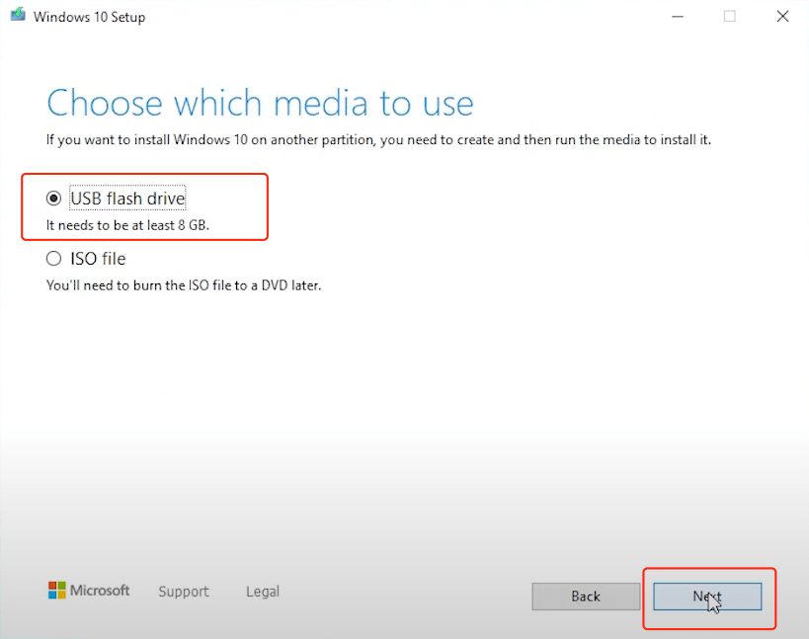

**Step 4:** Choose the USB drive plugged into your PC and click next. There should be a download that starts. You should close the setup window when it is done.

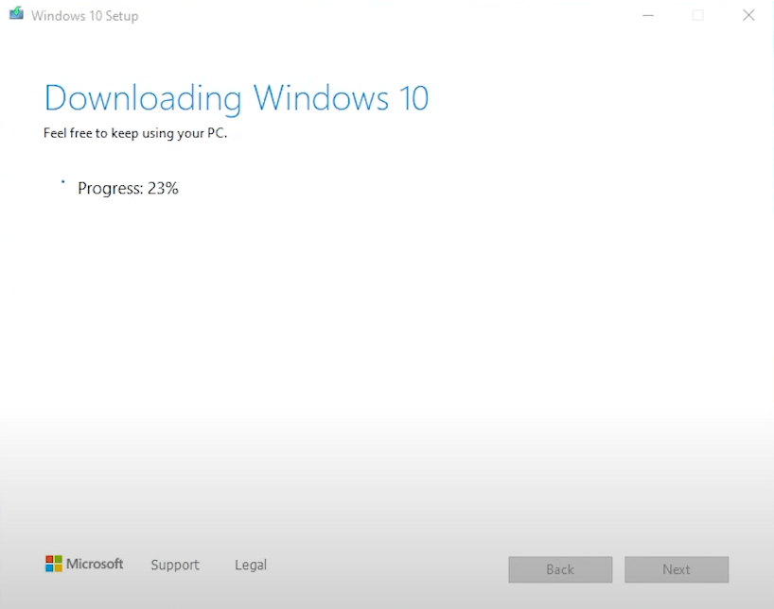

**Step 5:** Restart your PC then press and hold the f11, f2, f10, or del buttons until a boot menu appears. On the boot menu move to the Boot option and change the value to removable devices. ***It should look like this:***

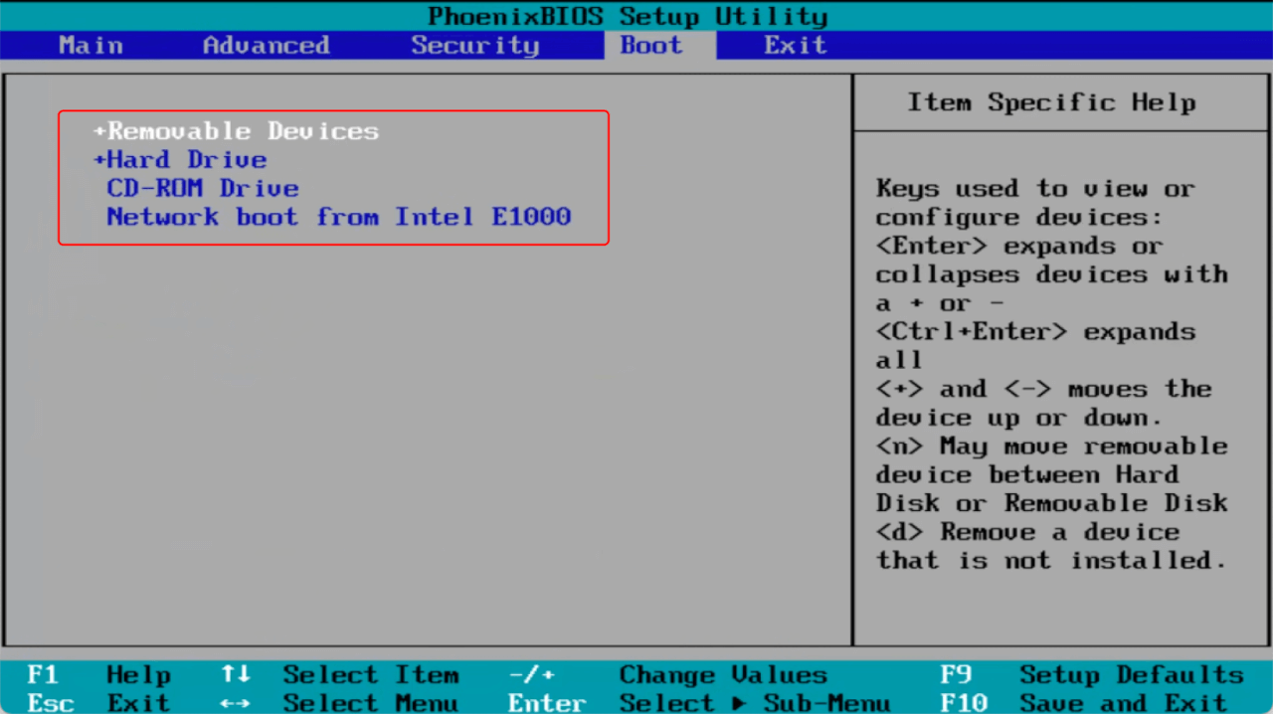

**Step 6:** On the windows setup choose a language and click next

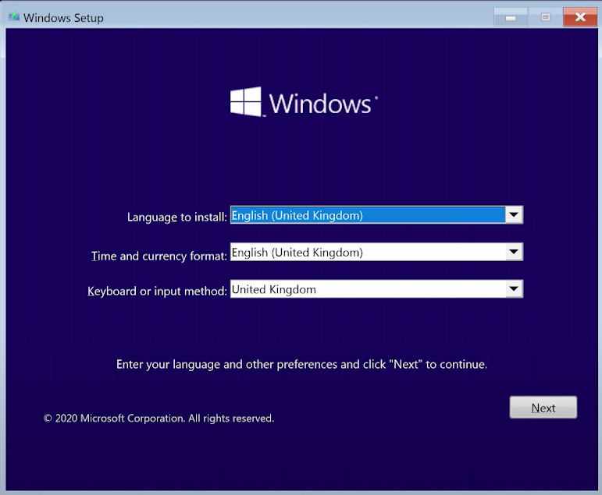

**Step 7:** Click Install and follow the prompts to set up Windows.

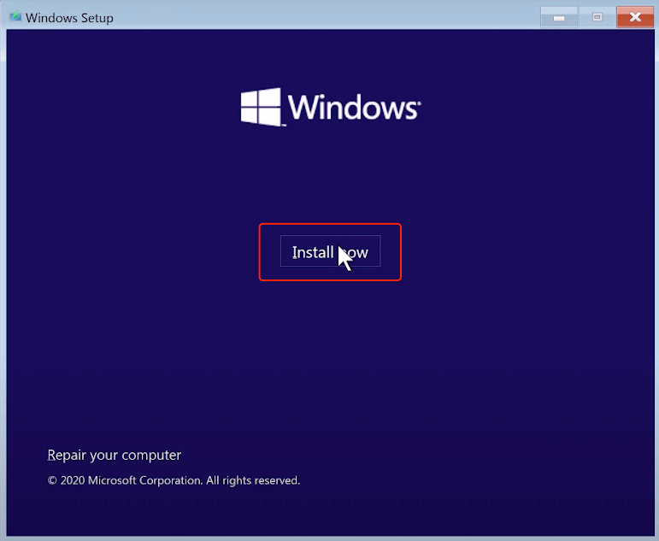

**Follow these post-installation steps and your Windows 10 PC will run smoothly and securely**

* Make sure Windows is activated.
* Update Windows 10 to the latest version for new features and security patches.
* Install the latest drivers for the graphics card, audio, networking, etc., for best compatibility.
* Install essential software like antivirus, [Office Suite](https://www.wps.com/academy/free-download-microsoft-office-for-pc(windows-10)/office-news/1863264/), creative apps, gaming clients, etc.
* Transfer data from a backup or old PC via transfer cable or cloud storage.
* Create a Windows restore point and recovery drive in case of any issues later.

# Visual Studio Code Installation

**Step 1:** Visit the [Official Website](https://code.visualstudio.com/docs/?dv=win) of Visual Studio Code using any web browser like Google Chrome, or Microsoft Edge and press the “Download for Windows” button on the website to start the download of the Visual Studio Code Application

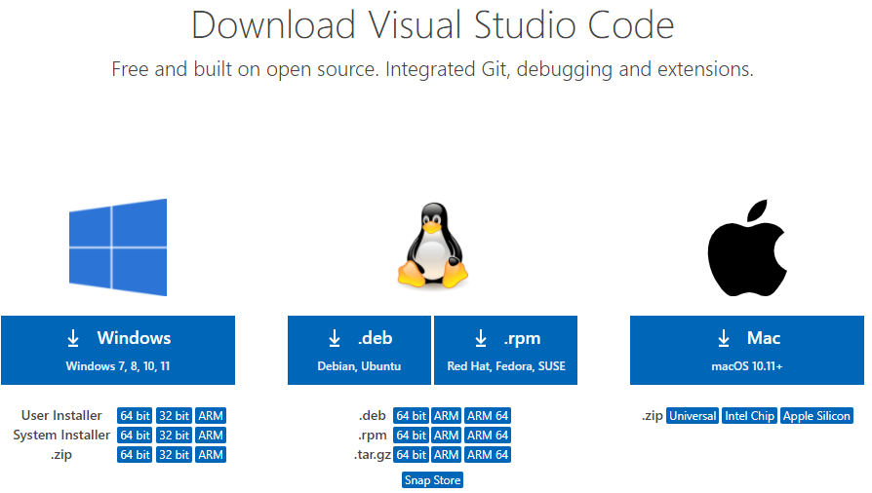

**Step 2:**  When the download finishes, then the Visual Studio Code Icon appears in the downloads folder, click on the Installer icon to start the installation process of the Visual Studi Coode

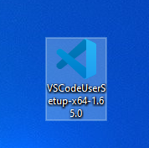

**Step 3:** After the Installer opens, you will accept the terms and conditions of Visual Studio Code. Click on I accept the agreement and then click the Next button.

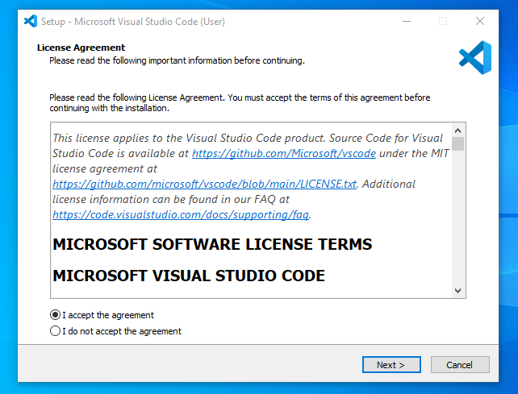

**Step 4:** Choose the location data for running the Visual Studio Code. It will then ask you to browse the location. Then click on the Next button. Finally, begin the installation setup by clicking on the Install button.

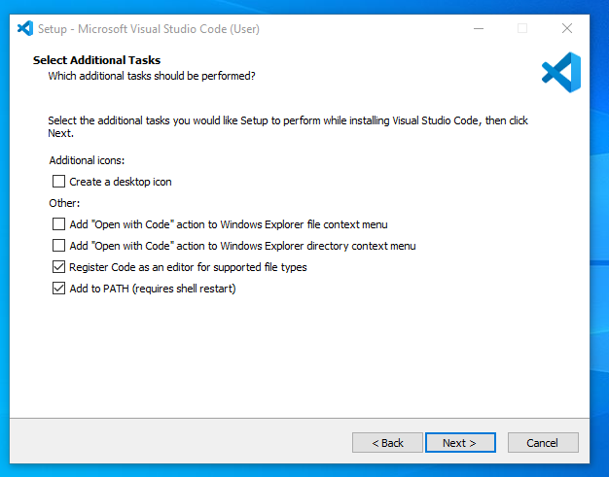

**Step 5:** The Visual Studio Code window should open successfully after you click “Finish”. Now you can create a new file in the Visual Studio Code window and choose a language of yours to begin your programming journey.

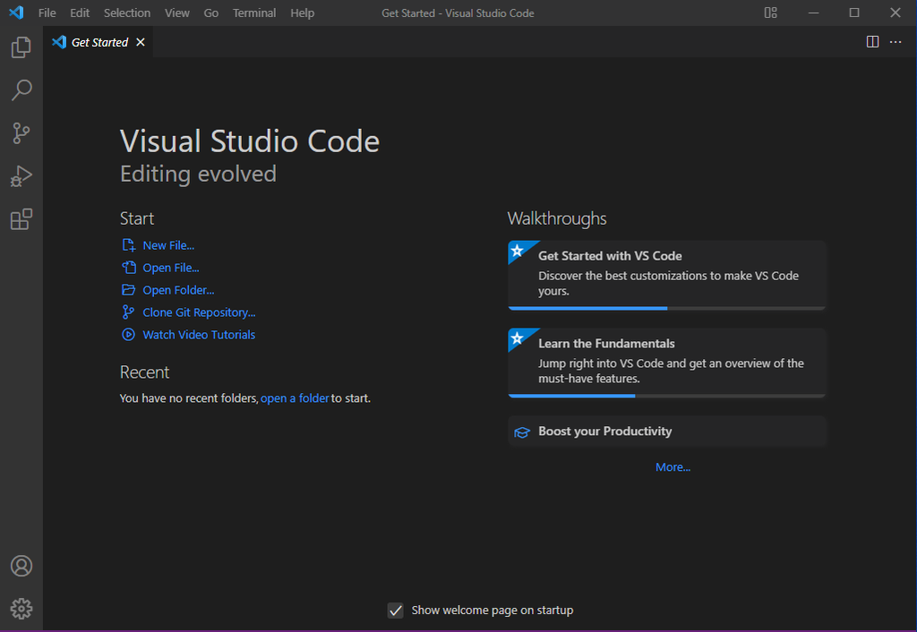

# Setting up Git bash and GitHub

**Step 1:** Download the [latest version of Git](https://git-scm.com/downloads) and choose the 64/32-bit version. After the file is downloaded, install it in the system.

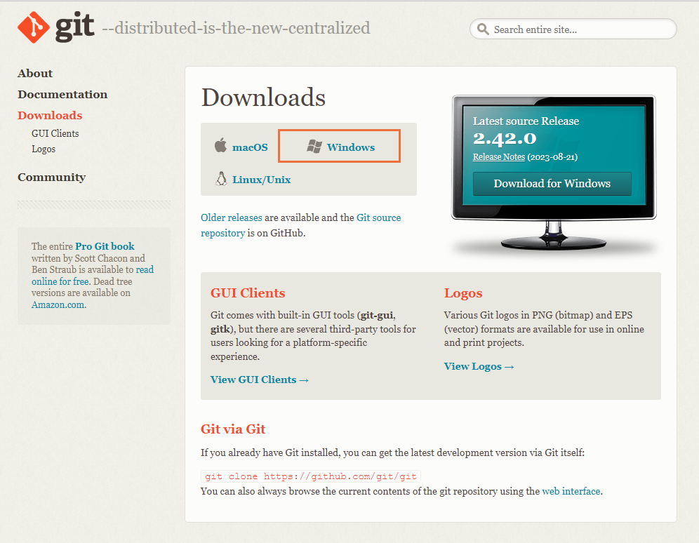

**Step 2:** Once installed, select Launch the Git Bash and choose where to install, then click on Finish. The Git Bash has now launched.

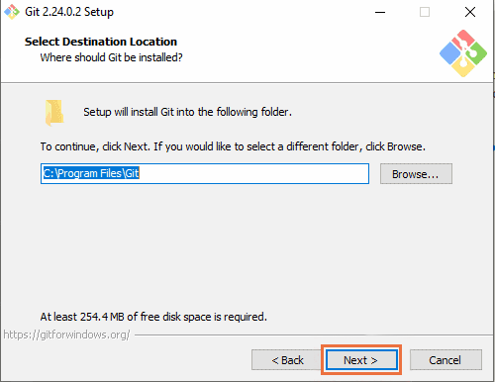

**Step 3:** From this point onward, it’s time to choose from various configuration options.

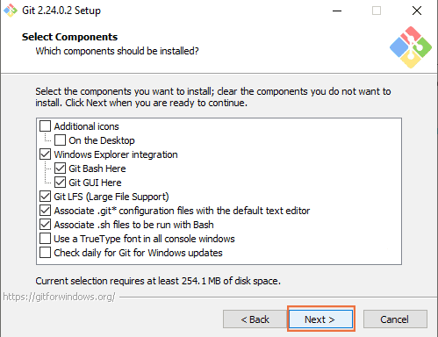

**Step 4:** Choose the default options with the recommended label on them and click next until you reach the last stage of the setup wizard. Then click Finish.

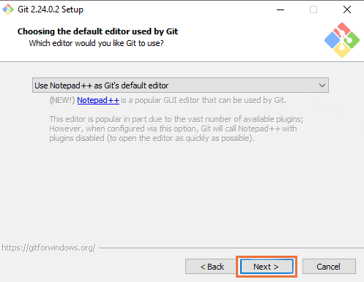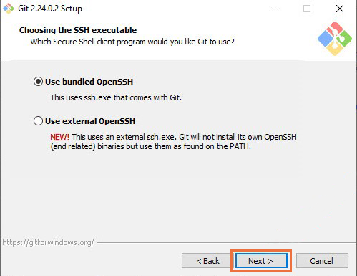

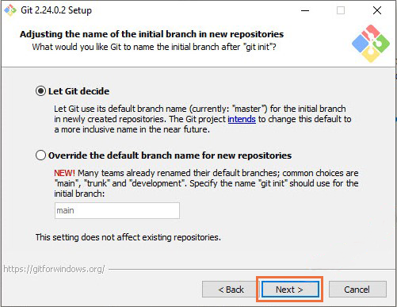

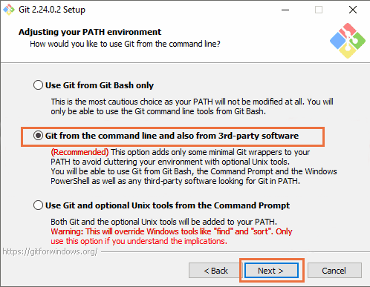

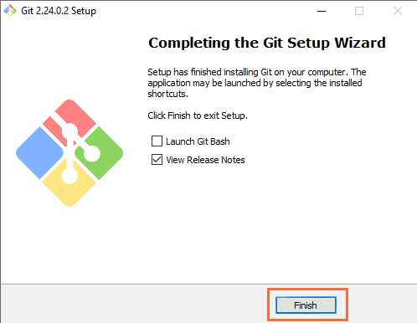

**Step 5:** After installing Git on Windows, to ensure that Git has been successfully installed, open a Command Prompt or PowerShell window and execute the following command:

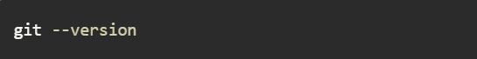

**Step 6:** Create a GitHub account. Go on your web browser search GitHub and go to the official page to create an account.



**Step 7:** Before launching Git on a Windows system, configuring your username and email address for Git is essential. Open a Command Prompt, PowerShell, or Git Bash window and execute the following commands:

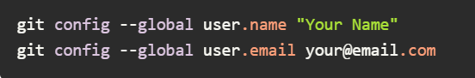

Replace “Your Name” and “your@email.com” with your Git account information.

# Python installation on Windows

**Step 1:** Visit the official page for Python. Locate a reliable/stable version of Python. Choose the correct link for your device either (64-bit) or (32-bit) and proceed to download the executable file.

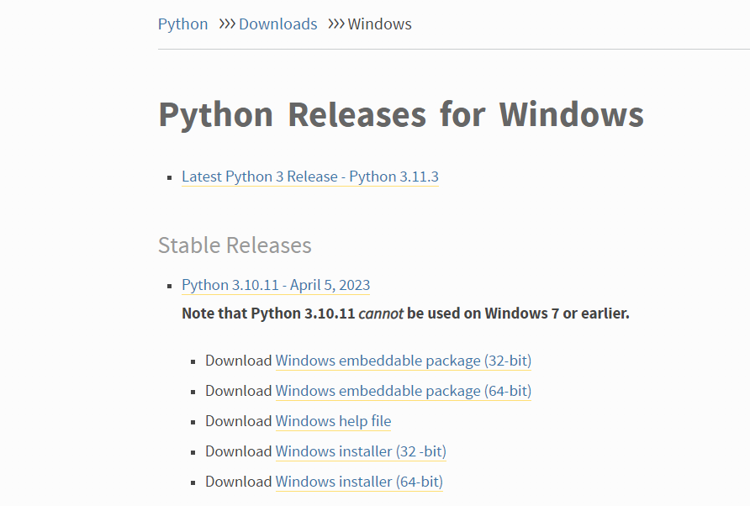

**Step 2:** After downloading the installer, open the .exe file, and choose the option to Install the launcher for all users by checking the corresponding checkbox. Enable users to run Python from the command line by checking the Add python.exe to PATH checkbox.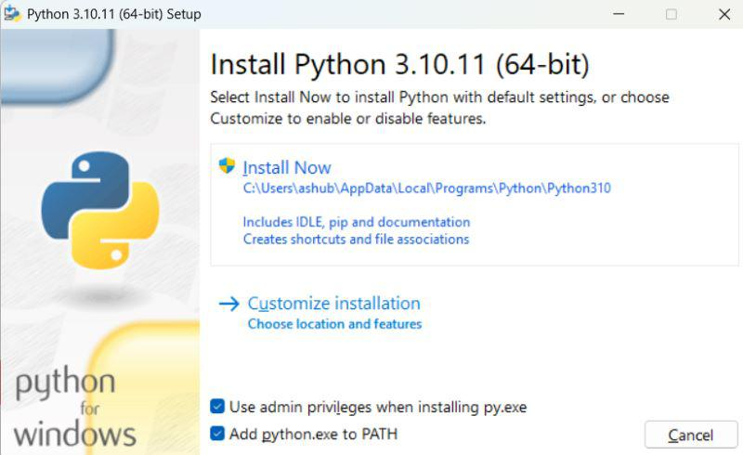

**Step 3:** After completing the setup. Python will be installed on your Windows system. You will see a successful message.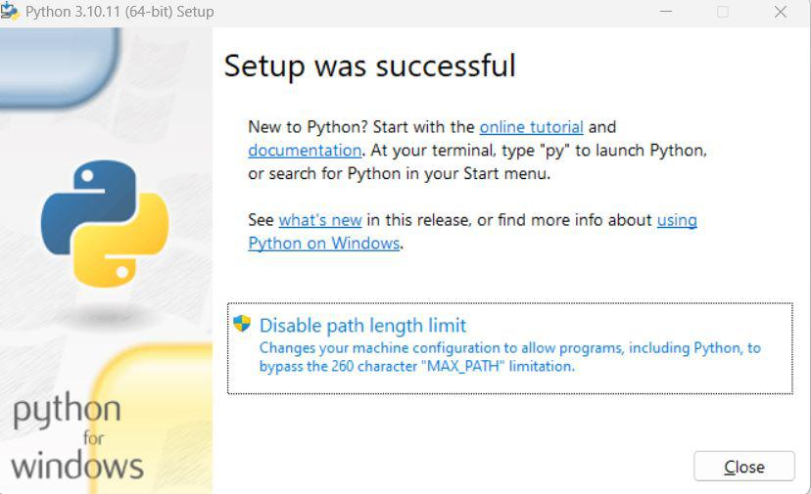

**Step 4:** Search environmental variables on your start menu and press enter, then go to environmental variables to edit the user variables. Double-click Path variable.

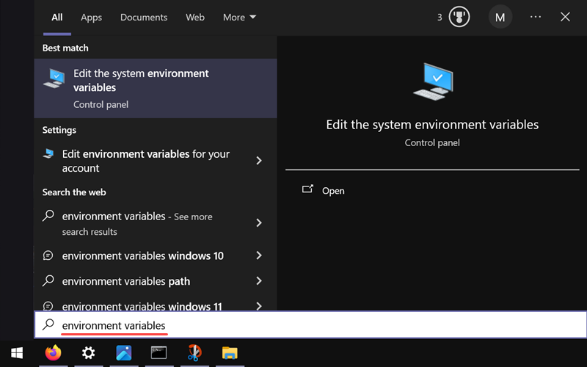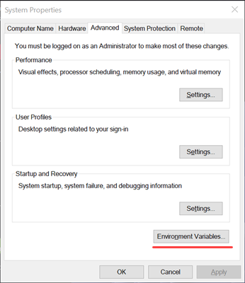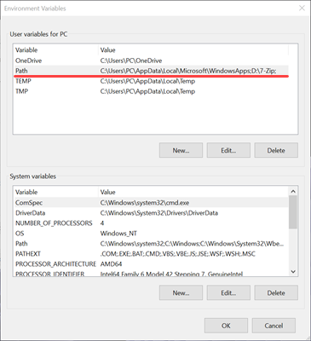

**Step 5:** Go to the location of the software in *C:\Users\lvmve\AppData\Local\Programs\Python\Python312* and copy the address, then paste the address into Path variable.

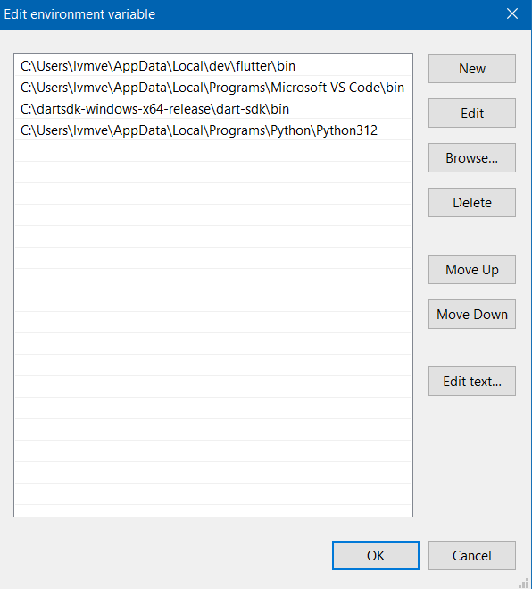

**Step 6:** After installing Python on Windows, ensure it has been successfully installed, open a Command Prompt or PowerShell window and execute the following command:



## 

## Install PIP on Windows Using ensurepip

**Step 1:** Open the command prompt and type the following command:

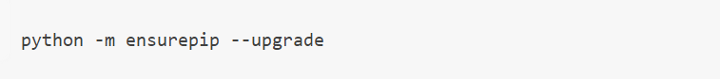

Wait for the installation to complete and it should say successfully installed pip at the last command line.

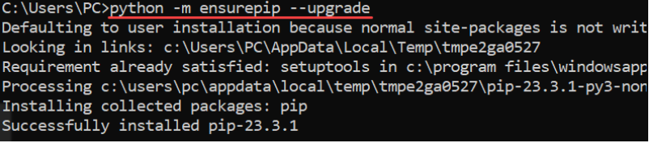

**Step 2:** Check if it is installed properly by entering this command:

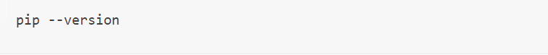

And the version should be output to the console



# Install MySQL for Windows

**Step 1:** Download the correct installer on the dev.mysql.com site.

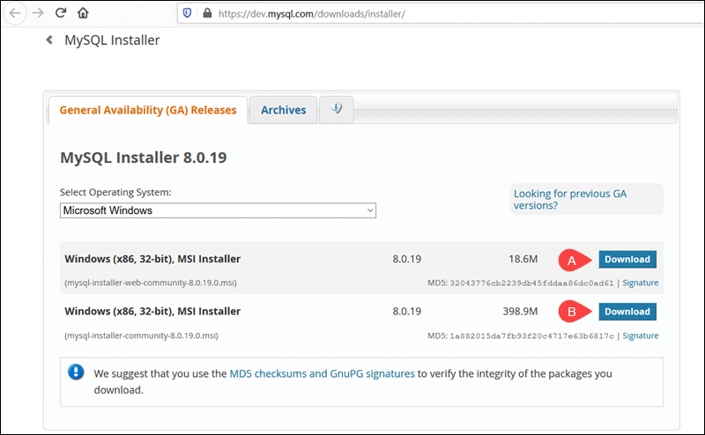

**Step 2:** Start the installation after completing the download. Choose “Server only option”

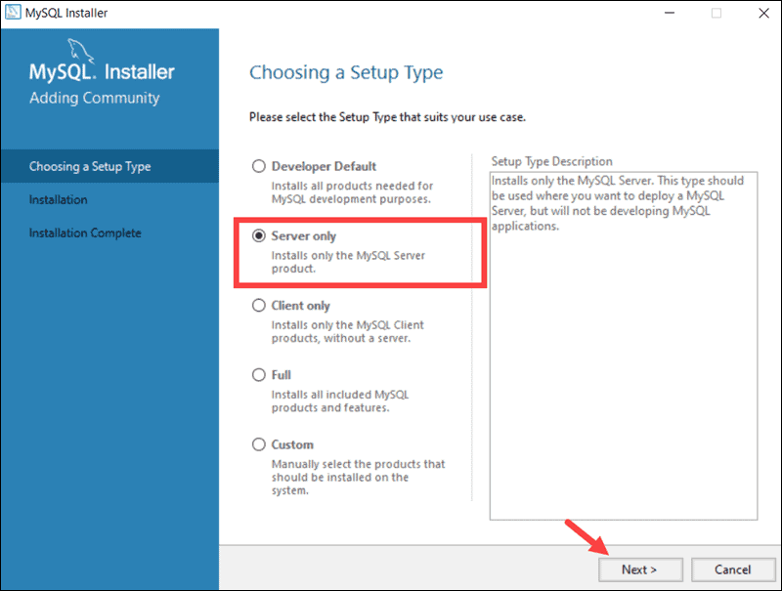

**Step 3:** Click on execute.

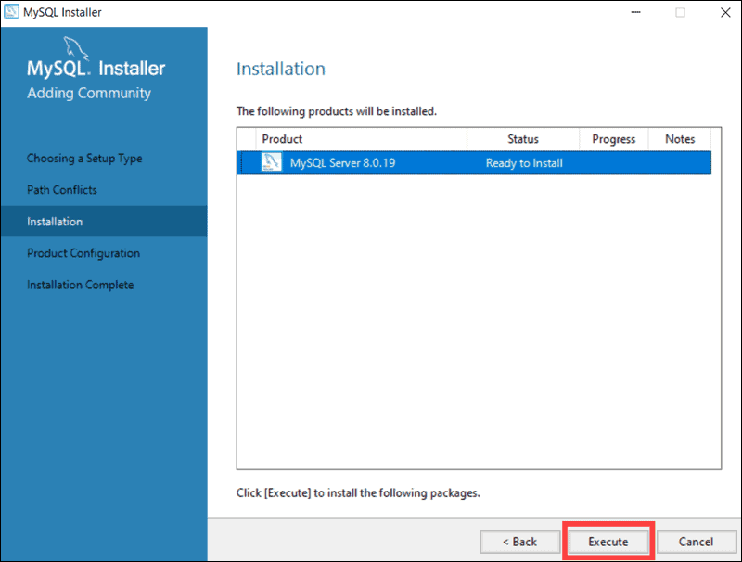

**Step 4:** Click on next to start the configuration. Follow the pictures and ensure all that's marked with red arrows is checked and clicked.

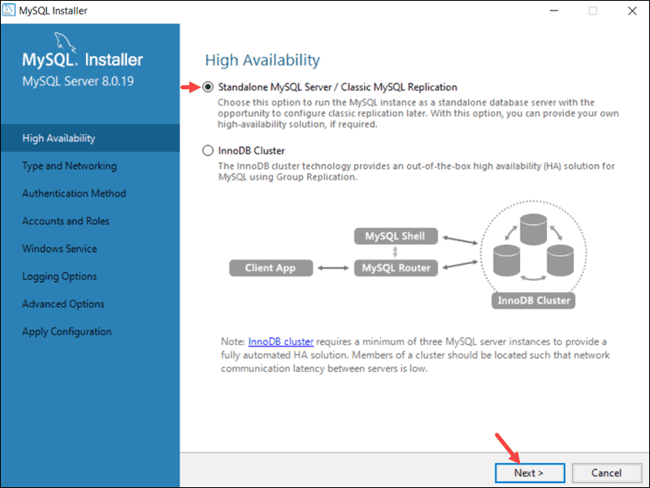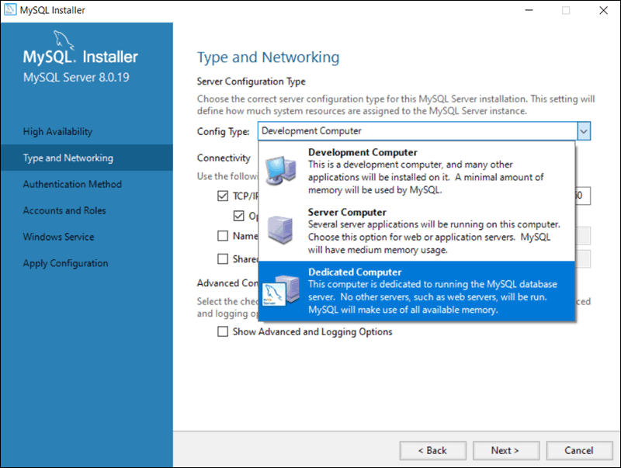

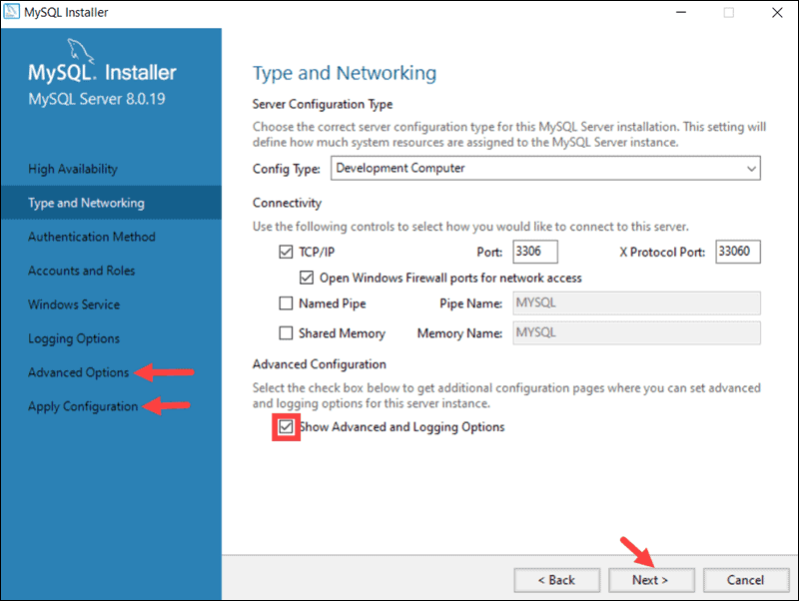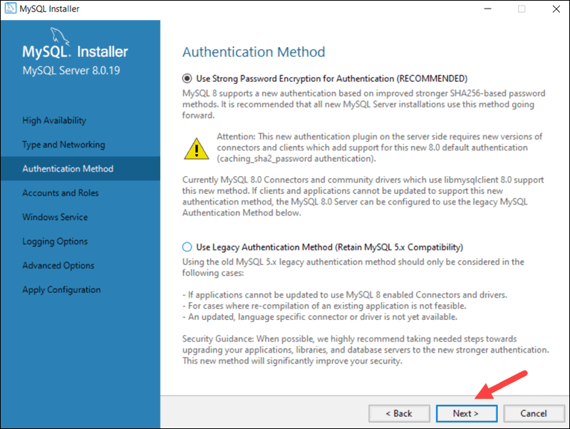

**NB: Create a root password that you won't forget**

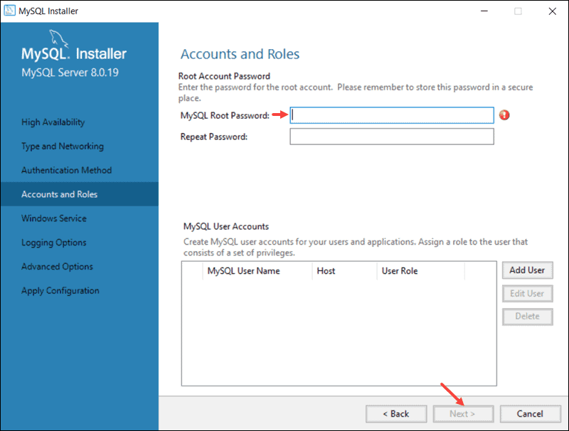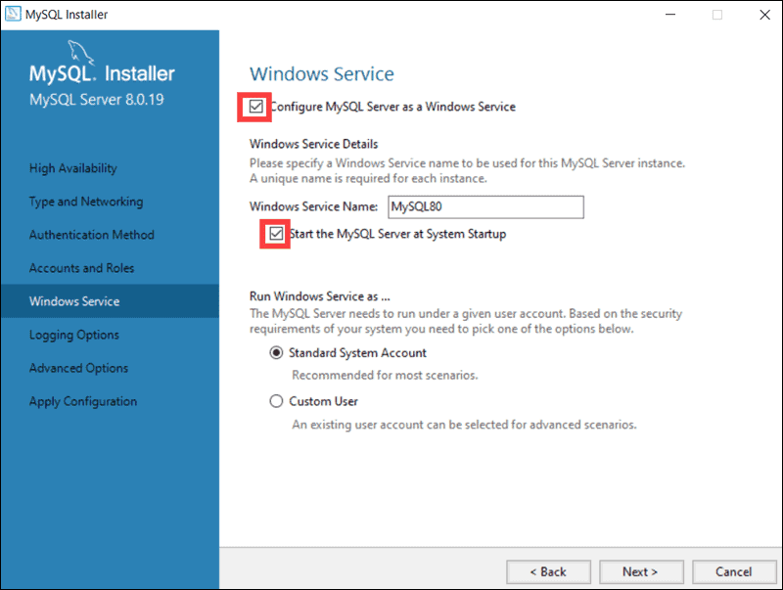

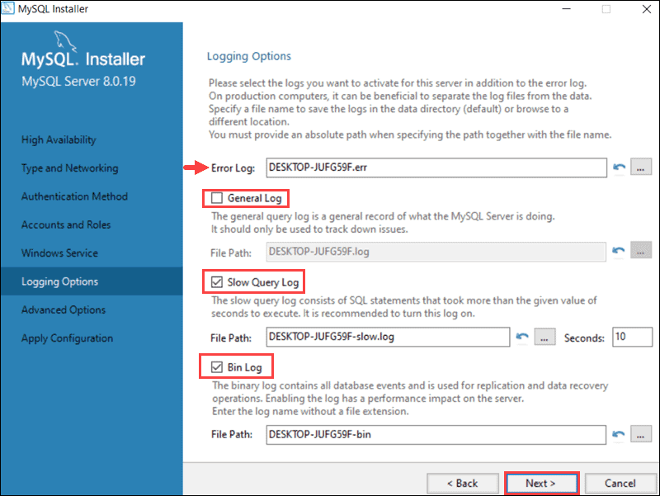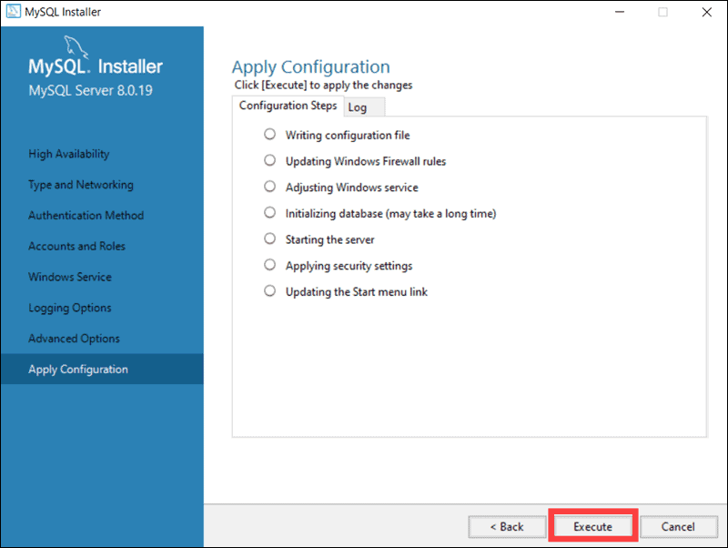

**Step 5:** To start the MySQL Server on Windows for the first time enter the following command in the Windows Command Prompt:



# My VS Code extensions

Here I've added pictures of the extensions I use on SV code. Some are for decorating my IDE and others are to help improve my code and help me avoid small mistakes developers make when coding.

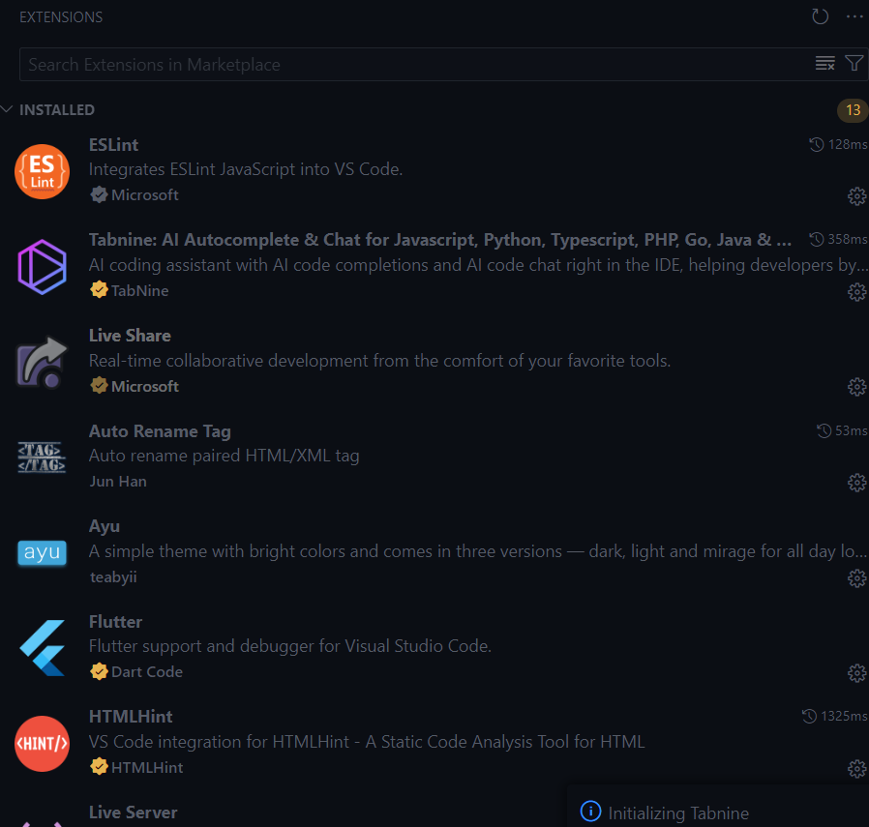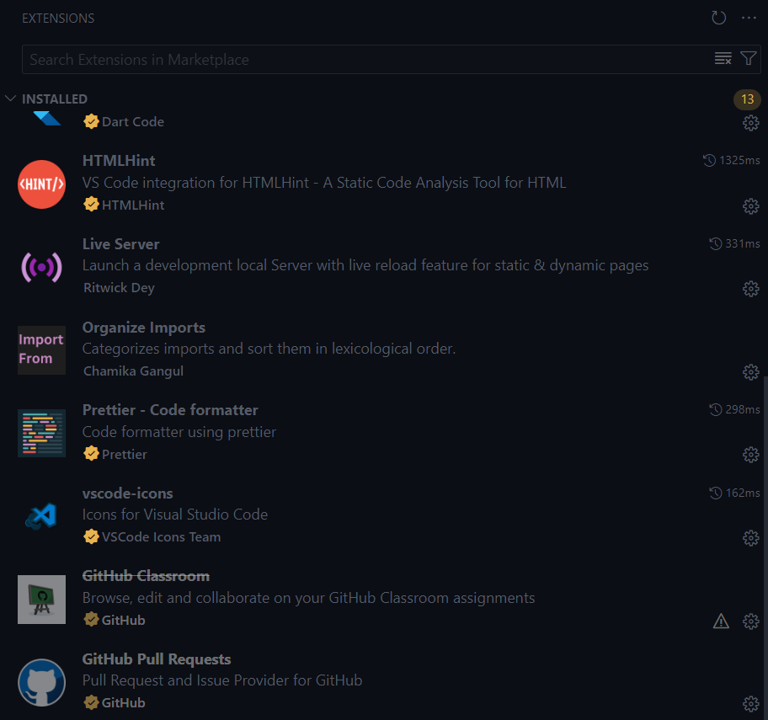

# Troubleshooting

* Ensure that you extract each file you download to C:
* Add your newly installed software to Path on environment variables
* Ensure that your PC is updated and restarted
* Ensure that you are using the latest and most compatible versions of the software that you install
* Don’t be afraid to consult YouTube and Google for other issues you experience.